Handout no. 12
Name
Reg. No
Marks/Grade

EXPERIMENT # 13
Modeling of Distance protection in MATLAB/ Simulink for Transmission lines protection
Objective:
At the end of this lab session students will be able to
- Use “Sim Power Systems” for modelling the power system.
- Implement “Impedance Relay” by using MATLAB Simulink Libraries.
- Set the impedance of “Impedance Relay”.
- Learn how to create an electrical subsystem.
Introduction:
Utilities are responsible for the generation, transmission and distribution of electricity to customers. Part of this responsibility is ensuring a safe but yet reliable power supply to customers. For the purpose of safety and protecting the transmission and distribution network from faults, utilities worldwide have sophisticated protective equipment. Collectively, these are known as secondary equipment and include the current transformers (CT), potential transformer (PT) and protective relays.
Protective relays:
A protective relay is one which monitors the current, voltage, frequency or any other type of electric power measurement either from a generating source or to a load for the purpose of triggering a circuit breaker to open in the event of an abnormal condition. In the electrical power system these relays are called as protective relays.
The function of protective relaying is to cause automatic removal of a part of the system, when it suffers a short circuit, or when it starts to operate in an abnormal manner that might cause damage or otherwise interference with the effective operation of the rest of the system. Relays are also used for the prompt removal of any part of the system from the service, for the purpose of maintenance.
Circuit Breakers:
Circuit breakers are generally located so that each generator, transformer, bus, transmission line, etc. can be completely disconnected from rest of the system. These circuit breakers must have sufficient capacity so that they can carry momentarily the maximum short-circuit current that can flow through them, and then interrupt this current.
Impedance Relay:
The impedance relay is used for protection of long transmission lines. If impedance is less than threshold circular value of relay than it will trip the breaker. If the value of impedance lies outside the circle than it will restrain the circuit breaker. So when fault occurs the current increases and voltage decreases and value of impedance will be decreased than threshold level.
Procedure:
Step 1: Draw a simple power system having a 3-φ Variable Source, 3-φ phase circuit breakers, 3-φ VI measurement unit, 3-φ RLC series load and block of 3-φ fault to implement different types of fault in system. Connect the blocks as shown below.

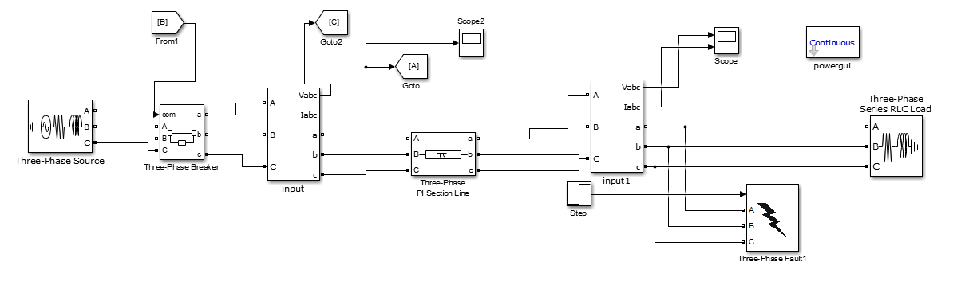
Figure 1: Block Diagram of three phase system

Set the parameters of each block as mentioned below. Accept default values for all other
Parameters.
Total Simulation Time: ?
Solver: Ode23tb (stiff/TR-BDF2)

Note: To select the solver go to menu bar > Simulation > Configuration Parameters OR press (Ctrl + E) and select the solver. Also set following solver options.

Relative tolerance: 1e-3 (default)
Solver reset Method: Robust
System Frequency: 50 Hz

Three phase Programmable Voltage source:
Voltage (Phase to Phase): 11e3 V
Internal connection: Y grounded
Specify impedance using short-circuit level: Select this option

Three-Phase Breaker:
Initial status of breakers: closed
Enable switching of all Phases
External control of switching times: Select this option
Measurements: None
Breakers resistance Ron: 0.001
Snubbers resistance Rp: 1e6
Snubbers capacitance Cp: inf

Three-Phase V-I Measurement:
Voltage measurement: phase-to-phase
Current measurement: Yes
(Uncheck labels and per-unit measurements)

Three-Phase Series RLC Load:
Configuration: Y grounded
Nominal voltage: 11e3 V
Active Power (MW): 200e6 W
Inductive reactive power: 100 VAR
Capacitive reactive Power: 0 VAR

Step 2: when the fault is introduced the voltage is decreased and current is increased but the overall the value of impedance will be decreased. If the overall value of impedance is less than threshold value than it will send trip signal to circuit breaker.
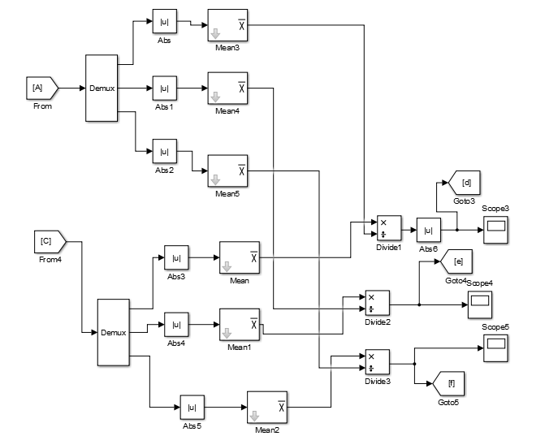

Figure 2: Impedance Relay

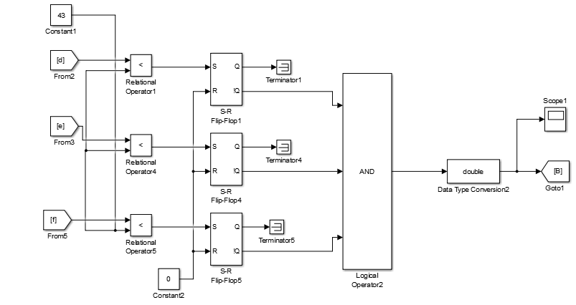
Figure 3: Impedance Relay

Observation and Results:

